**User Guide**

**X10 Upload CIBIL PDF Data**

2016

Installing Filezilla

To upload the PDF CIBIL files, we need ftp client application, in this case we will use Filezilla. Find and double click the Installation file (https://filezilla-project.org/download.php), and follow the instruction below.

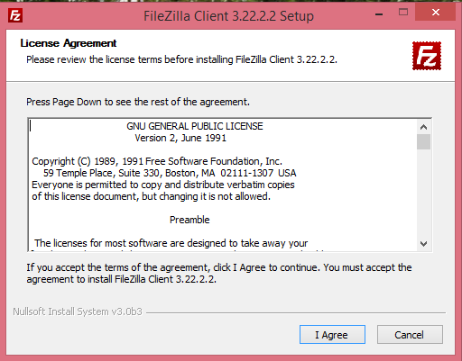

Click “I Agree”

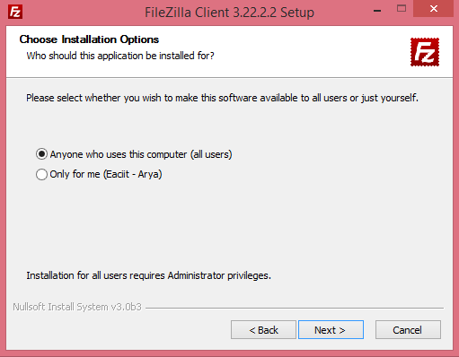

Choose “Anyone who uses this computer (all users)” and click “Next >”

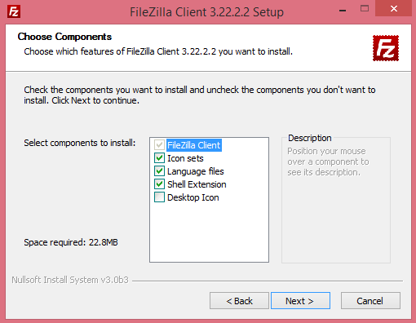

Click “Next >”

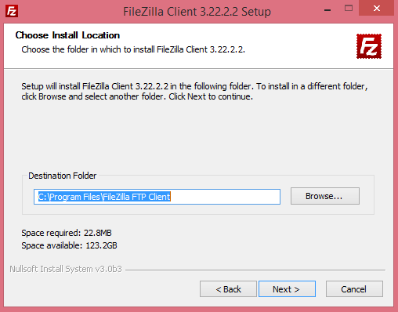

Choose installation directory, then click “Next >” and wait until installation process finish.

Setup Filezilla & Upload PDF

After Filezilla installed in your system, next we need to setup connection to the server. Follow the instruction below to setup Filezilla. This setup is required once to configure settings for a particular environment.

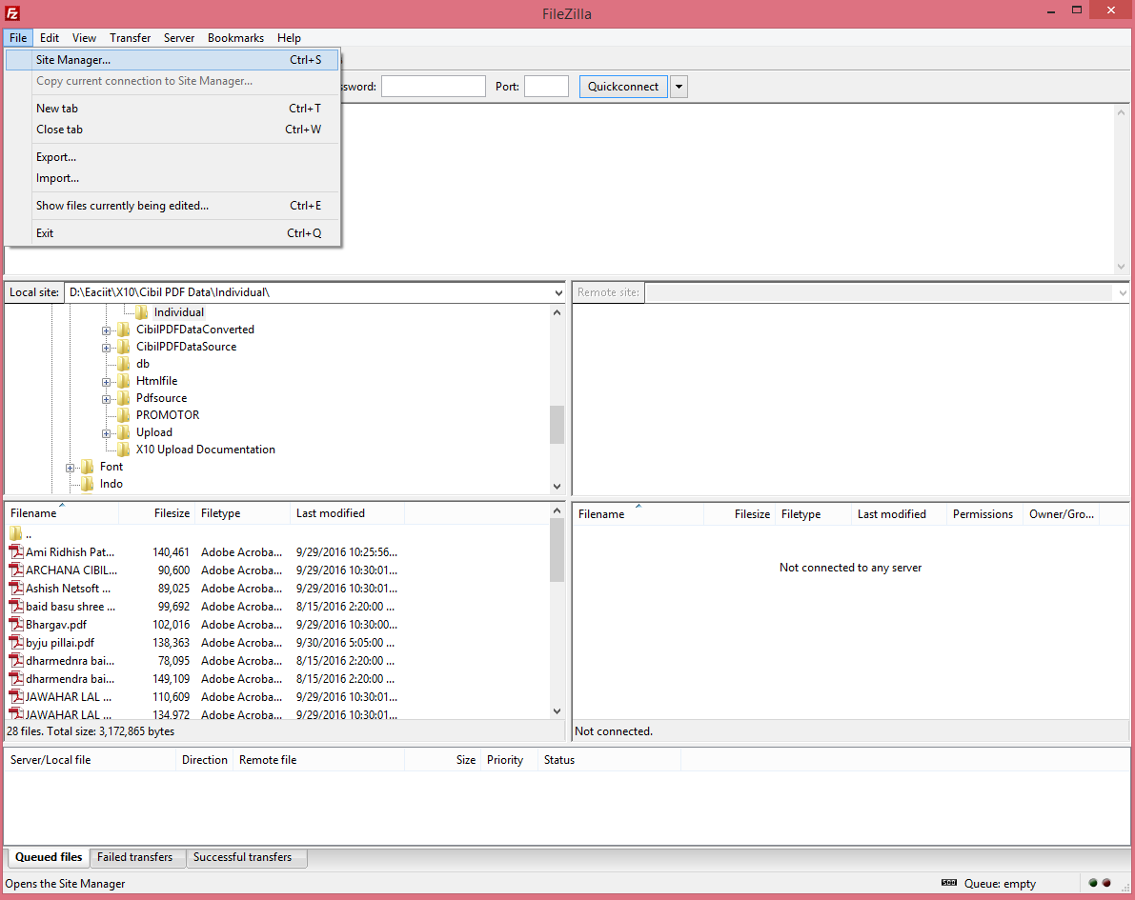

First, Open Filezilla and go to File -> Site Manager

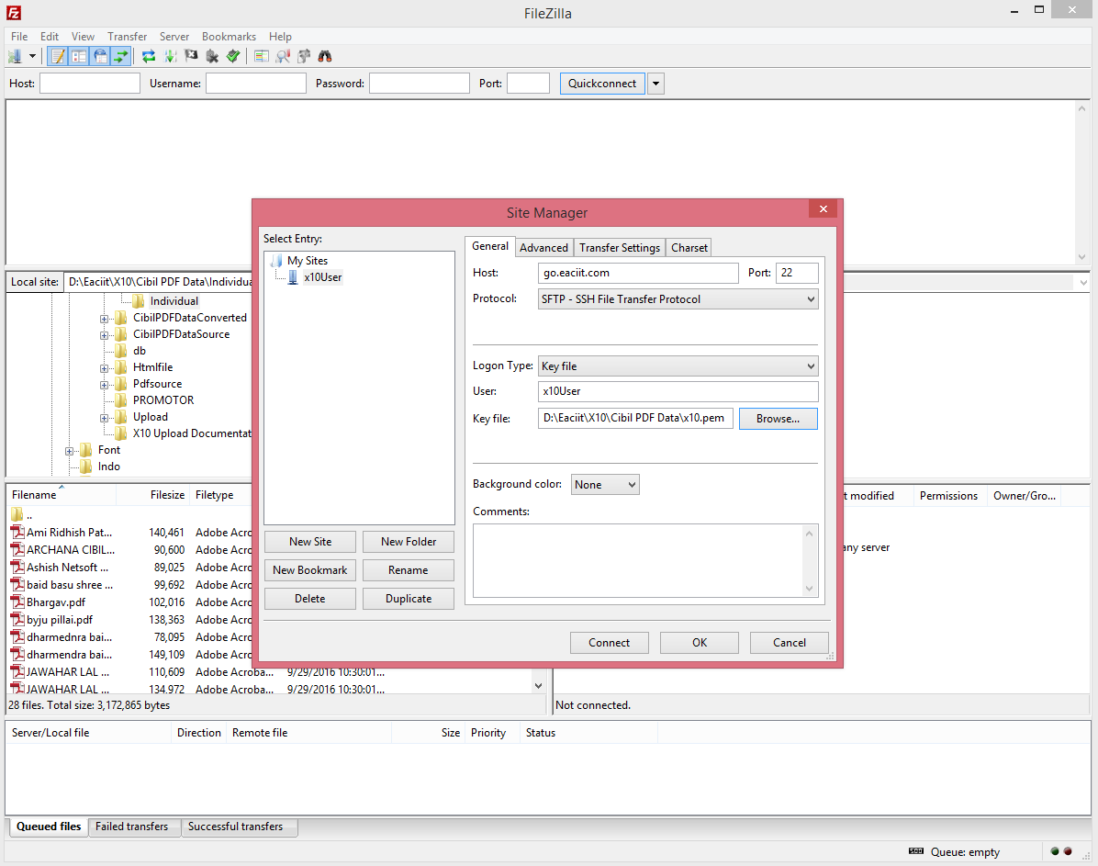

Click “**New Site**” then write the name of Server for example “**x10-user**” then go to right section.

Choose Protocol to “**SFTP – SSH File Transfer Protocol**” and file Host with “**go.eaciit.com**” Port “**22**” and then choose Logon Type as “**Key file**”, fill the User with “**x10-user**”.

For Key File, browse to **x10.pem** file, after that Click “**Connect**”. Next Time we just need to click “Connect” to connect to server.

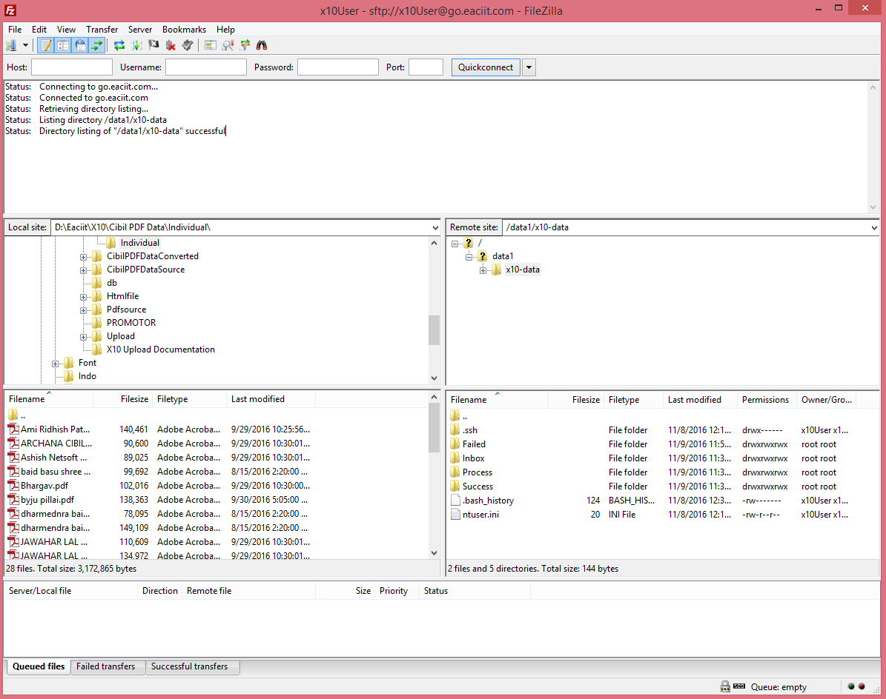After connected to Server, we will receive signal successful on top section, then we can access upload folder to copy the PDF Data.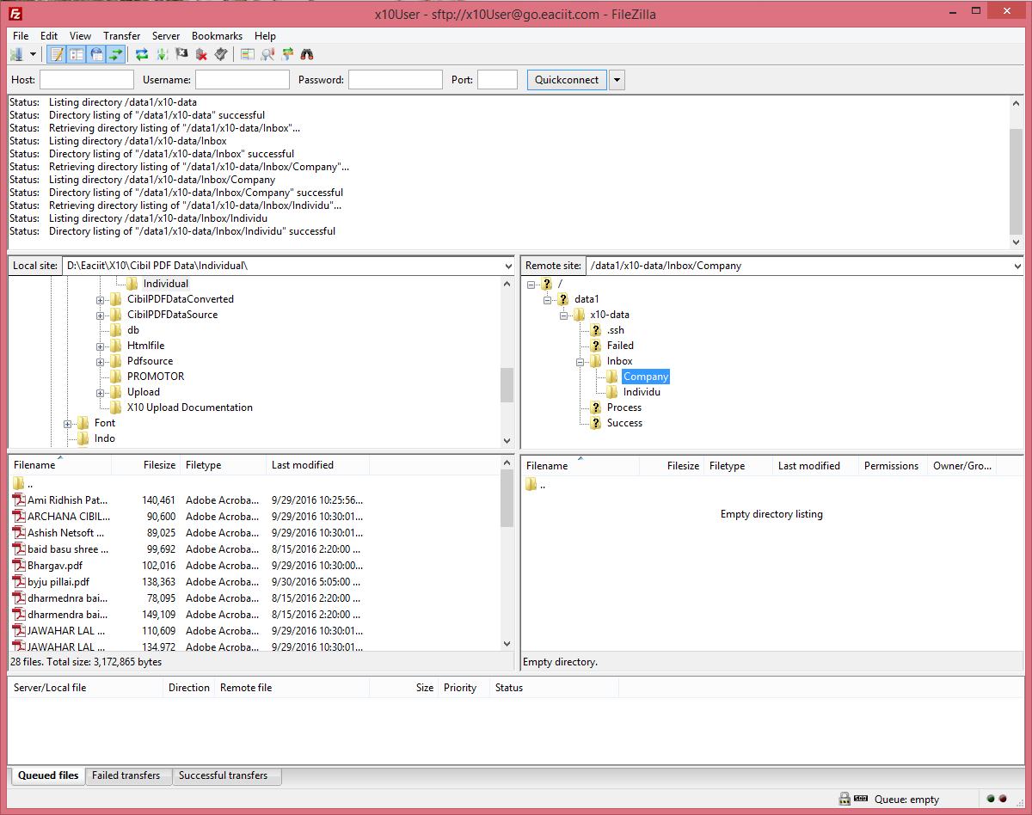

The left section is our local folder in our system and the right section is server folder. For uploading data from our system to server, first go to folder where the PDF file is saved in your system. To Upload PDF file for Company CIBIL go to “Upload -> Company” folder, and just drag and drop from left to the right.

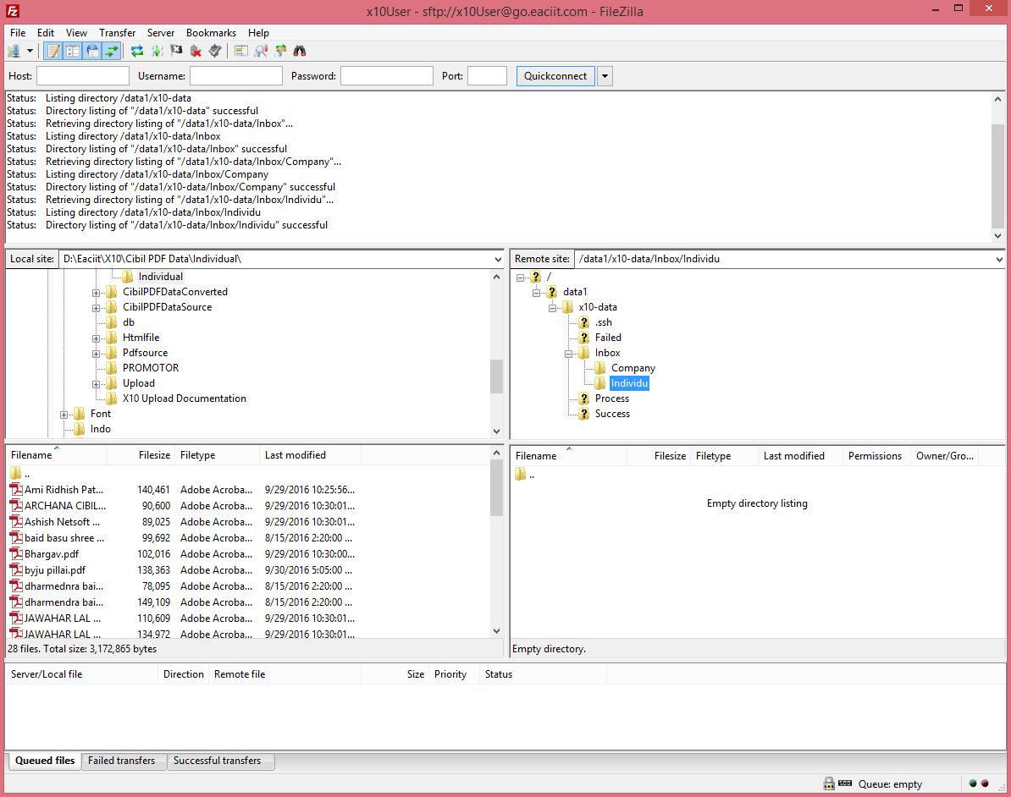

And for Individual CIBIL report go to “Upload->Individual” folder, and do the same thing. Files will be processed and uploaded on the database. The details can be checked on the Administrator->Edit CIBIL Details menu in the application.